EXAMPLE TWO

CSHS Management Class
Case Study Outline

The purpose of this exercise is to expand and deepen your perspective and your skillfulness as you function in your role as a leader and manager.
- You can expand your perspective by looking through the four lenses depicted by the four quadrants found below.
- You can deepen your perspective by considering the levels in each of the four quadrants as they move from very simple up to very complex.
- Remember, leaders do the right thing, and managers do those things right. You are both a leader and a manager.
- Managers plan, organize, staff, motivate and monitor.

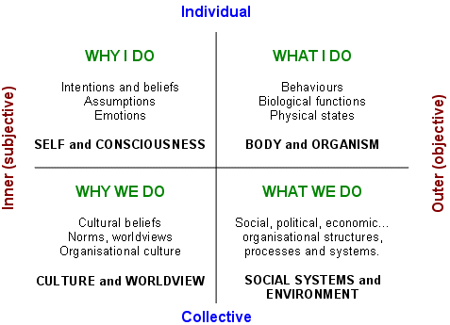

You have been seeded with a variety of books and articles about leadership and management issues. You can go back to www.andyatwood.com to refresh yourself at any time.

Now, here is your assignment.

Come to class prepared to share a story about how you functioned as a leader and manager, and share that story from all four quadrants/perspectives, and use any of the books and articles with which you have been seeded to amplify your story.

For example, let me share this story from my own work. Consider it my 2nd example of how to think through and write up a Case Study.

I recently found myself deeply impressed by one of the leaders with which I work. He and his wife recently went to China for almost three weeks, with there four children, to finalize their adoption of a 2 ½ year old, 18 pound little girl. Deeply religious and spiritual people, he and she moved me with their walk – which matched their talk. The last six months they have been remodeling their house for their bigger family.

What is going on inside these people (upper left) that called them to such action? (upper right) The only way I’m going to know is to sit with them and listen to their story as it unfolds.

Then, I began to wonder what the impact would be on this leader’s company, on his culture (lower left). An important tag line for the company is “DWWSWWD” – Do what we say we will do. I suspect that everyone in the company, maybe 70 people, has heard the story of what their leader has done with his personal life. They have heard about how he has spent his time and money. Based upon his actions, they are wondering what has gone on inside their leader. They are wondering about his values. They are seeing that he has a lot of integrity (left hand and right hand are aligned).

Now, I’m wondering about how this all translates into SOPs at the company. How will the company dedicate its time and money? Will the company’s values (lower left) and its SOPs (lower right) align? Will the company DWWSWWD?

Will another employee ask for some grace from the company to go on a mission trip with his church, for example?

Will customers experience the company’s integrity just as I experienced the leader’s integrity?

I’m going to be working with the leadership team at this company every month for the next year around strategic thinking and planning.

At our next meeting, I’ll share this document and encourage them to think from all four perspectives. Integrity of all four quadrants will be my goal.

I’ve got years practicing this way of thinking and working. When I consider a challenge from all Four Quadrants I have a greater probability of doing a thorough assessment, and creating a thorough intervention.

We are using the Inquiry <> Action <> Reflection model for learning that is used by so many educators around the world.

Pick a challenge in your world and give it a try. Use the tools with which you have been seeded and run it through all Four Perspectives. Make some notes and come to class prepared to share your story.

